Website name: Mapthology

Tagline: Designed map/plan maker just for sightseers.

Project Description: The website provides several services for sightseers. It has the ability to search for beautiful places by typing in the key words (Main.html). We provide plan maker (SearchMap, AddtoPlan.html), compare trails (Compare.html), Alert for new features (Alert.html) and fork different trails (Fork.html). Also, the website can navigate between pages by clicking buttons on the screen. The word on buttons shows the purpose of those buttons. I deleted two screens from the wireframe (compare search and compare) since I found that I can add those two features into other screens.

UI and interactions:

1. Main.html: it has logo, ads and search box with search button that will navigate to search map
2. AddtoPlan.html: User can see his/her plan, compare plan, start the plan and return to search map
3. Alert.html: User will be alert by newly discovered features sorted by distance.
4. Compare.html: User can compare multiple plans here and is able to add/search more plan to compare
5. Fork.html: User will need to choose one trail out of multiple choices.
6. SearchMap.html: User can see the search results on a real map.
7. Start.html: The map
8. Buttons will navigate between pages

Github link: <https://github.com/CS160-Summer2022/project-1-dliu49>

Youtube [Video](https://youtu.be/qXOm-dT9E74) Link

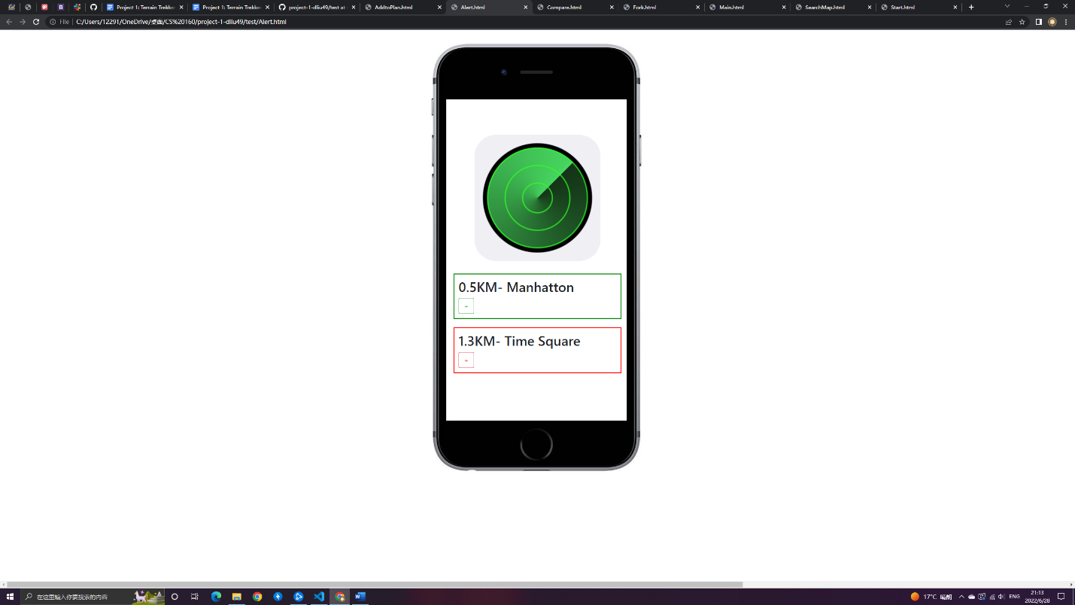

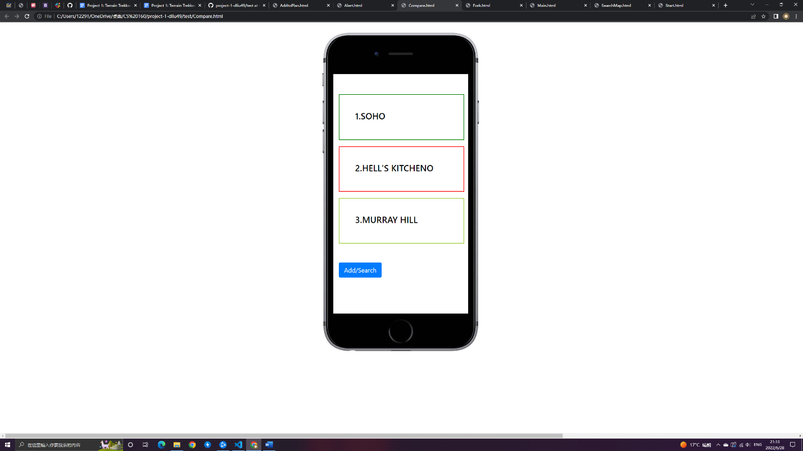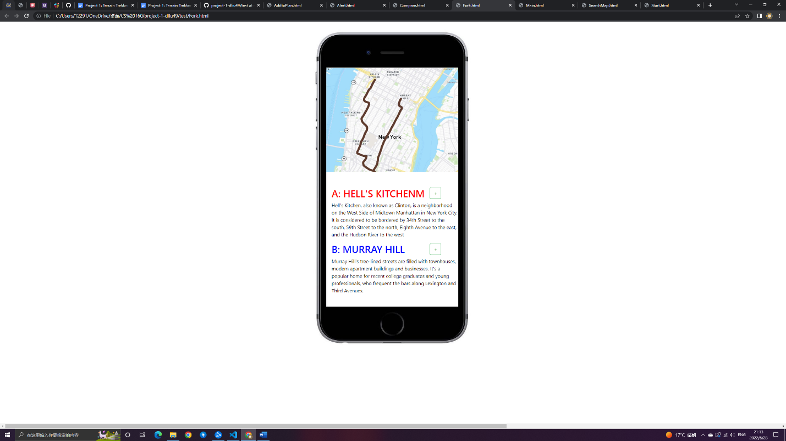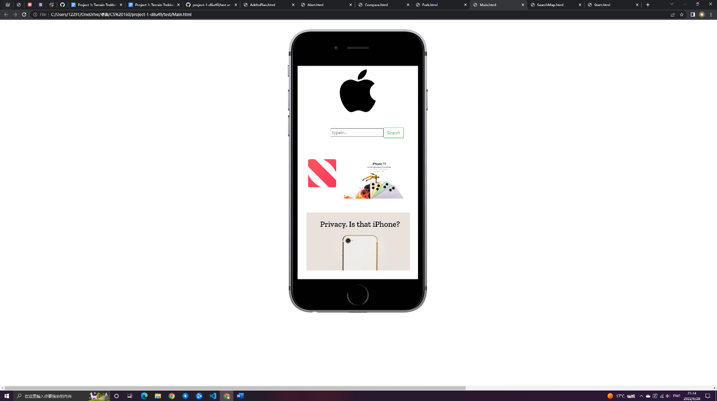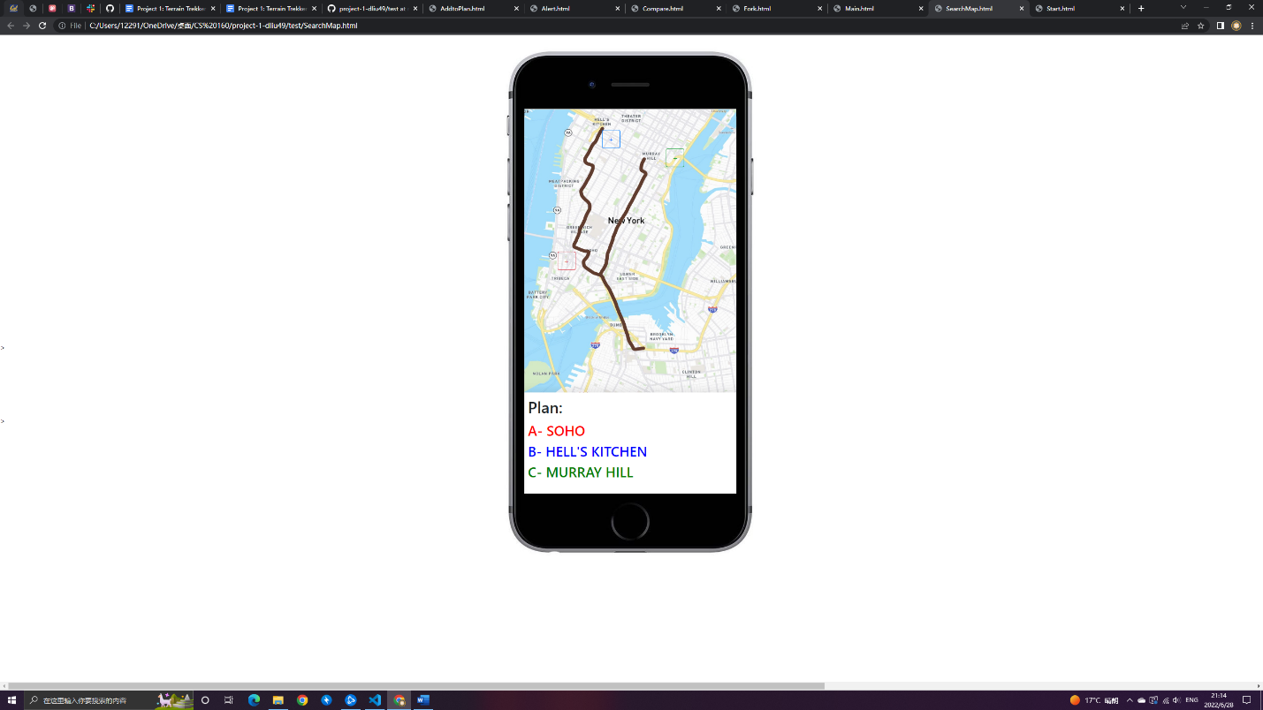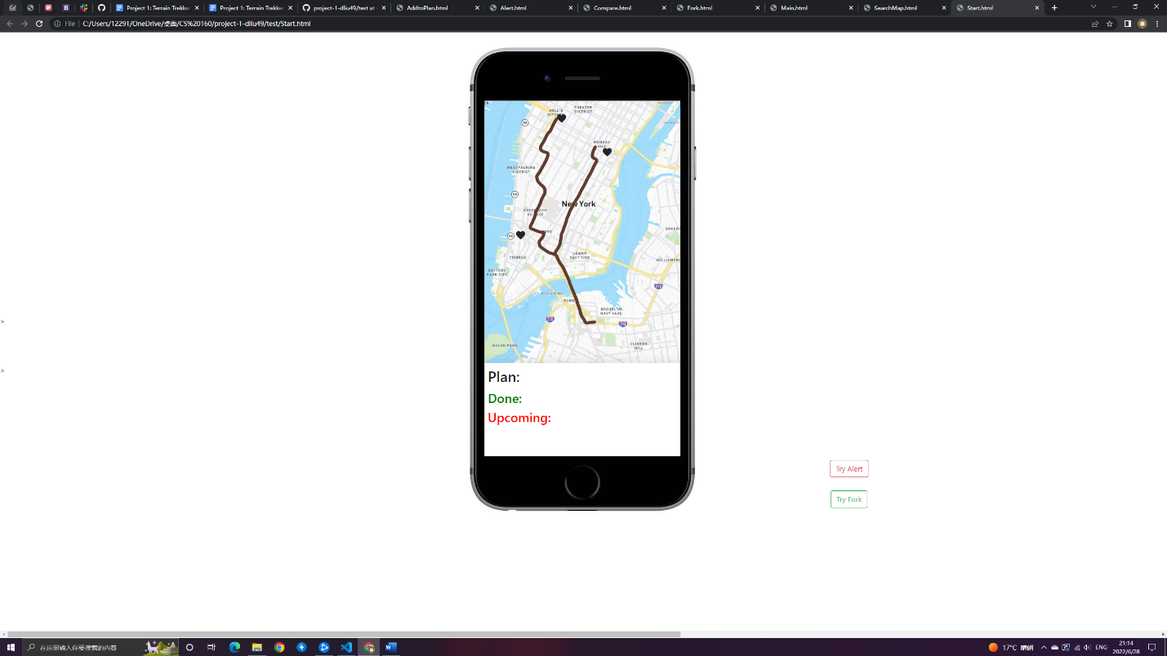

Credits for third party image and icons:

[iphone screen](https://www.pinclipart.com/pindetail/ihiboTb_free-png-download-iphone-png-black-and-white/)

[Buttons from bootstrap](https://getbootstrap.com/docs/4.0/components/buttons/)

[Search icon](https://www.pngwing.com/en/free-png-pypva/download)

[Apple Logo](https://1000logos.net/apple-logo/)

[Apple News Logo](https://macdailynews.com/2022/01/27/apple-news-is-now-the-most-popular-news-app-in-the-uk/)

[Apple Ads1](https://wccftech.com/apple-arcade-cunningly-takes-over-the-official-apple-website-new-video-ad-spot-launched/?beta=1)

[Apple Ads2](https://foundation.mozilla.org/en/blog/what-half-of-iphone-users-dont-know-about-their-privacy-new-poll/)